**Problem Statement**

**Product Dissection for top leading Platforms**

Welcome to this case study on dissecting and designing products for top leading platforms. In this case study, you will delve into the intriguing world of schema design for a prominent platform of your choice. Your task is to choose a top leading platform, research its features, and meticulously craft a schema design that encapsulates the essence of its functionality. By focusing on key entities, attributes, and relationships, you will gain invaluable insights into how data architecture drives the platform's effectiveness.

**Step 1: Choose a Leading Platform**

Select a leading platform of your choice, which could span various domains such as social media, e-commerce, finance, or any other industry. This choice will form the foundation of your exploration into its schema design.

**Step 2: Research:**

Thoroughly research the platform you have selected. Investigate its core features, functionalities, and user interactions. Identify the top features that define its user experience and contribute significantly to its popularity.

**Step 3: Product Dissection and Real World Problems solved by the platform**

In this step, you will meticulously analyse the platform's standout features and how they provide innovative solutions to real-world challenges. By identifying key functionalities that resonate with users, you'll unravel how the platform effectively addresses problems and enhances user experiences. This dissection will serve as the foundation for understanding how the schema design aligns with the platform's core objectives.

**Step 4: Case Study on the real world problems and approach to solving them**

In this pivotal step, you will expand on the real-world challenges uncovered in Step 3 through a comprehensive case study. Delve into specific instances where users encountered difficulties and showcase how the platform's unique features provided effective solutions. By dissecting the approach taken by the platform to overcome these challenges, you'll gain a deeper appreciation for the platform's user-centric design philosophy and how it shapes the schema design.

**Step 5: Schema Design Based on Top Features**

Based on the features you have identified, craft a schema design that reflects the platform's data structure. Focus on the key entities, attributes, and relationships that underpin the chosen features. Your schema should capture the essence of how the platform organises and utilises its data.

**Step 6: Rationale Behind the Design**

While creating the schema design, consider the rationale behind the platform's choices. Reflect on why certain entities and relationships were chosen and how they align with the platform's goals. This will help you understand the strategic decisions driving the schema's architecture.

**Step 7: Create an ER Diagram**

Utilise tools like the Miro platform or similar applications to create an illustrative Entity-Relationship (ER) diagram. This diagram should vividly depict the entities, attributes, and relationships present within your schema design. The ER diagram will serve as a visual representation of your insights.

**Step 8: Presentation of Findings**

Present your findings in a clear and concise manner. Showcase your understanding of how the schema design impacts the platform's functionality and user experience. Explain how your chosen features are integrated into the schema and how the schema's structure supports the platform's objectives.

**Task Details:**

1. **Answer Submission:** Your submission should include well-structured solutions for all provided questions related to product schema designs.
2. **Video Creation:** Create an informative and engaging video where you thoroughly explain the Case Study.
3. **Depth and Clarity:** Ensure your solutions are detailed and showcase your understanding of product schema design principles. Similarly, in the video, provide clear explanations that are easy to understand for a wide audience.
4. **Creativity Encouraged:** You are welcome to utilise visuals, diagrams, or creative elements to enhance the clarity and impact of your explanations.

**Note:**

1. Duplicate this document and proceed to write your solutions and prepare your video.
2. Include the video link in this document before final submission.

Best of luck in completing this project and showcasing your prowess in dissecting and designing product schema for leading platforms! **For reference, we have also conducted a case study on Instagram, which you can find below. This case study will provide you with valuable insights into how schema design plays a pivotal role in shaping the functionality and success of a prominent platform.**

 

**Product Dissection for Twitter**

**Company Overview**

Twitter, founded in 2006 by Jack Dorsey, Noah Glass, and Biz Stone, has transformed the way people communicate and share information in real-time. Known for its character-limited posts (tweets), Twitter has become a global social media phenomenon, offering a platform for public discourse, news sharing, and user engagement.

**Product Dissection and Real-World Problems Solved by Twitter:**

Twitter effectively addresses real-world challenges through its innovative product offerings. With a focus on concise, real-time communication, Twitter empowers users to share their thoughts, breaking news, and opinions, bridging the gap between individuals and global events. This core feature solves the problem of accessing information quickly and engaging in discussions on a wide range of topics.

Twitter's ingenious features, such as retweets, likes, and trending topics, have revolutionized how users interact with content. By addressing the challenge of information overload, Twitter enables users to discover and amplify content that matters to them. Furthermore, the use of hashtags has transformed content discovery, allowing users to categorize their tweets with keywords. This innovative approach effectively addresses the challenge of navigating through a sea of content to find relevant information and engage in conversations that matter.

In conclusion, Twitter's product design has successfully tackled real-world problems by creating a platform that encourages real-time conversations, content curation, and meaningful discovery, shaping the digital landscape and providing practical solutions to the evolving needs of its global user base.

**Case Study: Real-World Problems and Twitter's Innovative Solutions**

Twitter, a leading social media platform, has not only revolutionized the way we share and consume information but has also addressed significant real-world challenges through its innovative features. By identifying user needs and leveraging technology, Twitter has positioned itself as a solution-driven platform that fosters connections, encourages real-time communication, and enhances digital interactions.

**Problem 1: Accessing Information Quickly**

**Real-World Challenge:** In an era of information overload, accessing timely and relevant information can be a daunting task.

**Twitter's Solution:** Twitter recognizes the need for quick and real-time information sharing. With character-limited tweets, users can share news, opinions, and updates in a concise manner. This solution addresses the problem of information overload by allowing users to access bite-sized, immediate information on a wide range of topics.

**Problem 2: Engaging in Conversations on Global Events**

**Real-World Challenge:** Engaging in meaningful conversations about global events and trending topics can be challenging.

**Twitter's Solution:** Twitter's trending topics feature enables users to discover and engage in discussions about events and topics that are currently popular or relevant. This addresses the challenge of finding conversations that matter, as users can easily join discussions, share their perspectives, and stay informed about the latest developments.

**Problem 3: Content Amplification**

**Real-World Challenge:** Users often struggle to make their voices heard in the digital noise.

**Twitter's Solution:** Twitter's retweet and like features allow users to amplify content that resonates with them. This solution empowers users to share and promote content, helping it reach a wider audience and addressing the challenge of content amplification in a crowded online space.

**Problem 4: Navigating Through a Sea of Content**

**Real-World Challenge:** Finding relevant information and engaging in conversations can be challenging in a vast sea of content.

**Twitter's Solution:** The use of hashtags allows users to categorize their tweets with keywords. Users can easily discover tweets related to their interests, solving the problem of content navigation and helping them engage in conversations that matter to them.

**Top Features of Twitter**

1. **Tweets:** Twitter's core feature, allowing users to share short text messages (tweets) in real-time.
2. **Retweets:** The ability to repost another user's tweet, amplifying its reach.
3. **Likes:** The option to like tweets, indicating approval or agreement.
4. **Hashtags:** Categorization of tweets with keywords to enhance discoverability.
5. **Trending Topics:** Real-time lists of popular and relevant topics.
6. **Followers and Following:** The platform fosters connections through the "Follow" functionality. Users can follow other accounts to see their tweets in their feed, creating a network of connections.
7. **Replies:** Users can reply to tweets, fostering conversations and interactions.

**Schema Description**

The schema for Twitter involves multiple entities that represent different aspects of the platform. These entities include Users, Tweets, Retweets, Likes, Hashtags, Trending Topics, and more. Each entity has specific attributes that describe its properties and relationships with other entities.

**User Entity:**

* **UserID (Primary Key):** A unique identifier for each user.
* **Username:** The chosen username for the user's account.
* **Email:** The user's email address for account-related communication.
* **Full_Name:** The user's full name as displayed on their profile.
* **Bio:** A brief description that users can use to express themselves.
* **Registration_Date:** The date when the user joined Twitter.

**Tweet Entity:**

* **TweetID (Primary Key):** A unique identifier for each tweet.
* **UserID (Foreign Key referencing User Entity):** The user who created the tweet.
* **Content:** The text of the tweet.
* **Creation_Date:** The date when the tweet was created.

**Retweet Entity:**

* **RetweetID (Primary Key):** A unique identifier for each retweet.
* **TweetID (Foreign Key referencing Tweet Entity)**: The tweet being retweeted.
* **UserID (Foreign Key referencing User Entity):** The user who retweeted the tweet.
* **Retweet_Date:** The date when the retweet was posted.

**Like Entity:**

* **LikeID (Primary Key):** A unique identifier for each like.
* **TweetID (Foreign Key referencing Tweet Entity):** The tweet being liked.
* **UserID (Foreign Key referencing User Entity):** The user who liked the tweet.
* **Like_Date:** The date when the like was registered.

**Hashtag Entity:**

* **HashtagID (Primary Key):** A unique identifier for each hashtag.
* **Tag:** The actual text of the hashtag.

**Trending Topic Entity:**

* **TrendingTopicID (Primary Key):** A unique identifier for each trending topic.
* **Topic:** The text of the trending topic.

**TweetHashtag Entity:**

**TweetHashtagID (Primary Key):** A unique identifier for each association.

**TweetID (Foreign Key referencing Tweet Entity):** The tweet associated with the hashtag.

**HashtagID (Foreign Key referencing Hashtag Entity):** The hashtag associated with the tweet.

**Schema Relationships**

* **Users create Tweets** – Each user can create multiple tweets.
* **Users retweet Tweets** – Users can retweet multiple tweets, and each tweet can have multiple retweets.
* **Users like Tweets** – Users can like multiple tweets, and each tweet can have multiple likes.
* **Tweets include Hashtags** – Tweets can include multiple hashtags, and each hashtag can be associated with multiple tweets.
* **Trending Topics include Tweets** – Trending topics can include multiple tweets, and each tweet can be associated with multiple trending topics.

**Entity-Relationship Diagram (ER Diagram)**

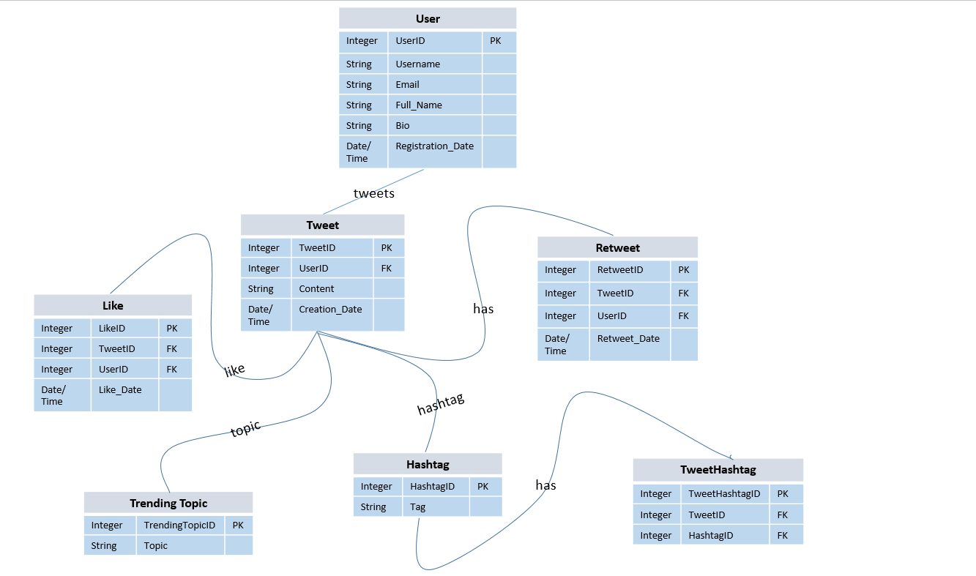

**Conclusion**

In this case study, we explored the schema design of Twitter and its innovative solutions to real-world problems. In this case study, we explored the design of a Twitter-like database schema, representing the core elements of a social media platform. This schema efficiently models users, tweets, likes, retweets, hashtags, and their relationships, fostering a dynamic and engaging user experience. By understanding this schema, we gain insight into how Twitter-like platforms effectively manage user interactions, content sharing, and trending topics, contributing to their popularity in the realm of social media.